2016

Verissa Owusu

ID: 63192019

4/19/2016

COMPUTER PROGRAMMING FINAL PAPER

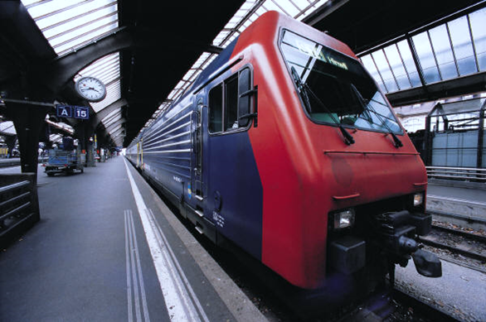

**CONTENTS**

**Page**

1. **Abstract 2**
2. **Introduction 3**
3. **Methodology 4 & 5**
4. **Case Study 6 - 9**
5. **Conclusion 10**
6. **Appendix 11**

**ABSTRACT**

This paper is a final paper for the course computer programming for CS and contains a final project. The project is centered on using concepts treated in class such as decision structures, objects and graphics, functions, classes and loop structures and Booleans among others.

This paper also contains the ideology behind a project which is a game. This game is a matchmaking game where the user has to guess which two boxes match, that is have the same picture.

The game programmed is to enable communication between people of sound hearing and speech and deaf and dumb people.

**INTRODUCTION**

This project is a game that displays 5 boxes to a user, the two boxes which the user thinks match are clicked. It is a guess game so after every game, the game has to be restarted in order to play again.

The game is based on the 26 alphabets in English which have been displayed in the sign language format.

Sign language is what I chose to center my project on because I have two older siblings who are deaf and dumb and whenever I am asked how I communicate with them I say, “I use sign language.” But there is a saying, “you can’t teach an old dog new tricks.” Thus the problem was how to teach people sign language through a fun and faster approach, hence a game.

**Problem**: finding a fun way to teach individuals who were not originally taught sign language in their early years sign language in order to facilitate communication between them and people with hearing disabilities.

**METHODOLOGY**

First of all, in order to create this game, a graphical user interface is needed. Hence the graphic module was chosen. Since a program has to be easily understood by its user, statements had to be displayed to give a description of the program. This was implemented using text methods in the graphics module.

The ideology behind the game requires that boxes be drawn on a Graphics Window, in order to do this the class Rectangle in the graphics module was called and since five boxes needed to be drawn the clone method had to be invoked.

The images are the sign language display of the 26 alphabets, in order to make the game a guessing game, a randomizer function is called so it randomly picks a number from 1 to 26 and then runs the necessary codes.

Next some boxes have to be clicked in order for an image to be displayed. In order to make sure that the user clicked on the box, for the image to be displayed, decision structures have to be implemented. With the use of the mouseclick() function and getX() and getY() methods coordinates of the mouseclick() function were used to check if they corresponded with the coordinates of the boxes using if statements, which when satisfied draws the respective images.

Decision structures are used again in order to check the matches in the game. When the two boxes match, a statement showing that the user won is displayed else a statement showing the user lost is displayed.

When the two boxes match then the user has won, if not the game was lost.

The user can also play multiple times just by clicking on a “Play Again” button which restarts the game.

**CASE STUDY**

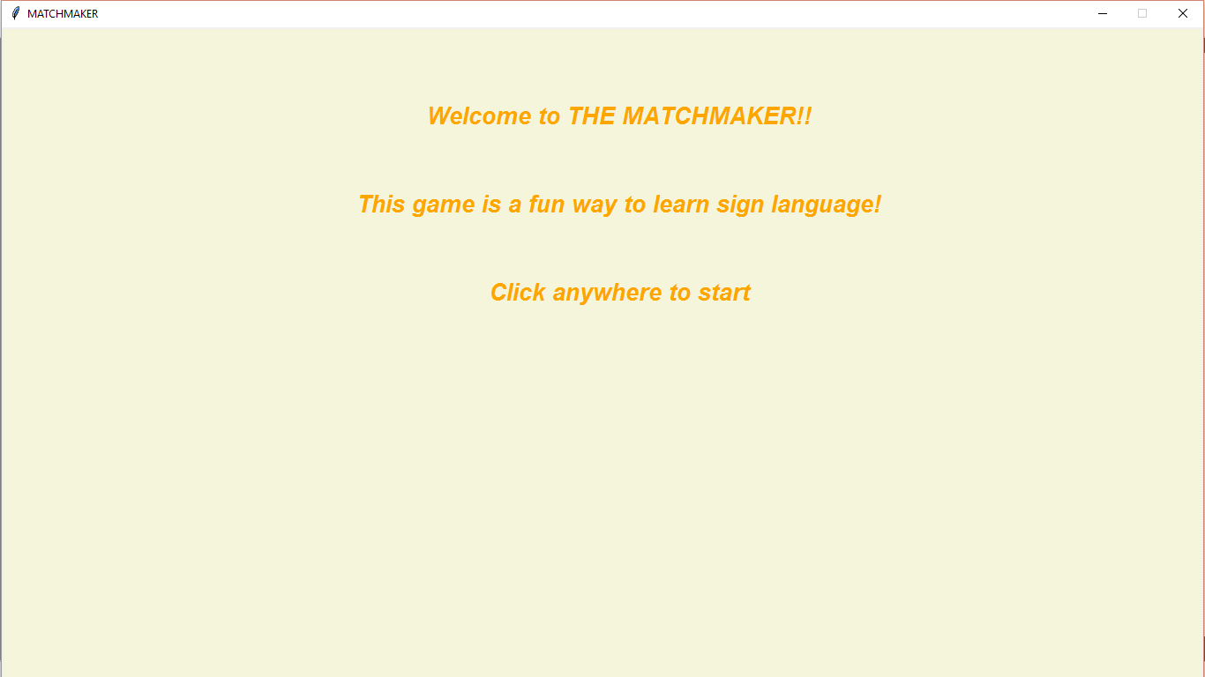

Figure Figure 1 above depicts the first graphical user interface when the program is run. It displays some instructions which guide the user as to what to do next.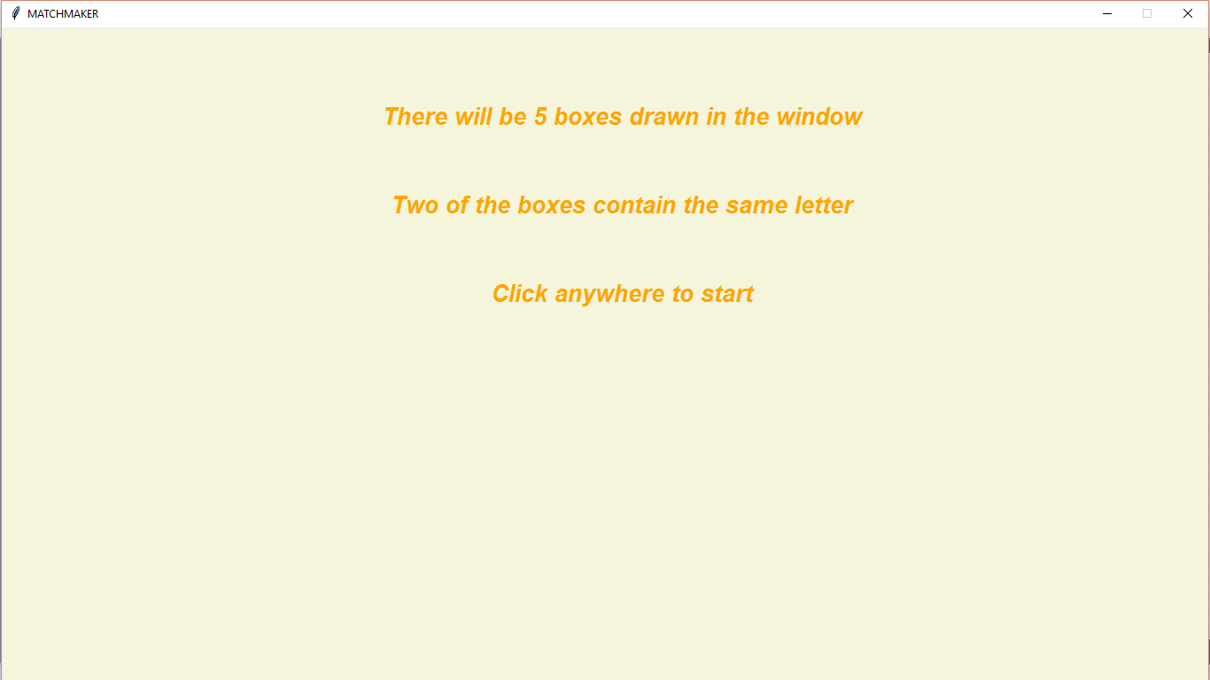

Figure

When the instructions in Figure 1 are followed. The user is redirected to an interface depicting further instructions as shown in Figure 2.

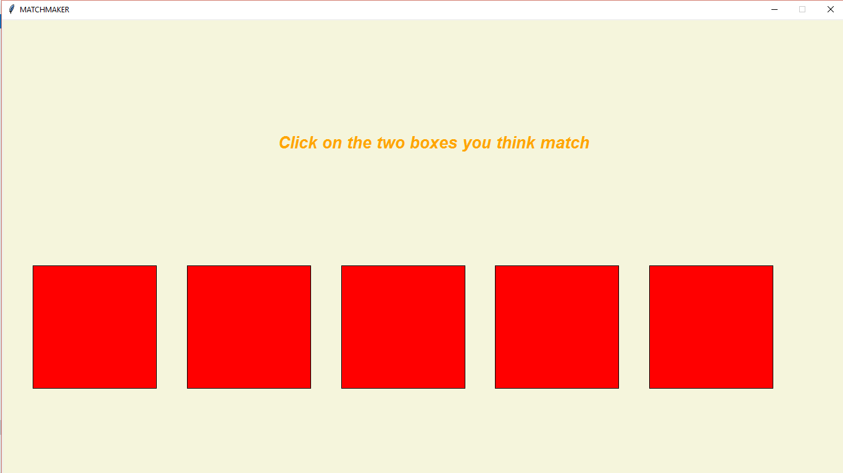

Figure

Figure 3 shows the 5 boxes drawn to the user in order for him to click on the two boxes he thinks match.

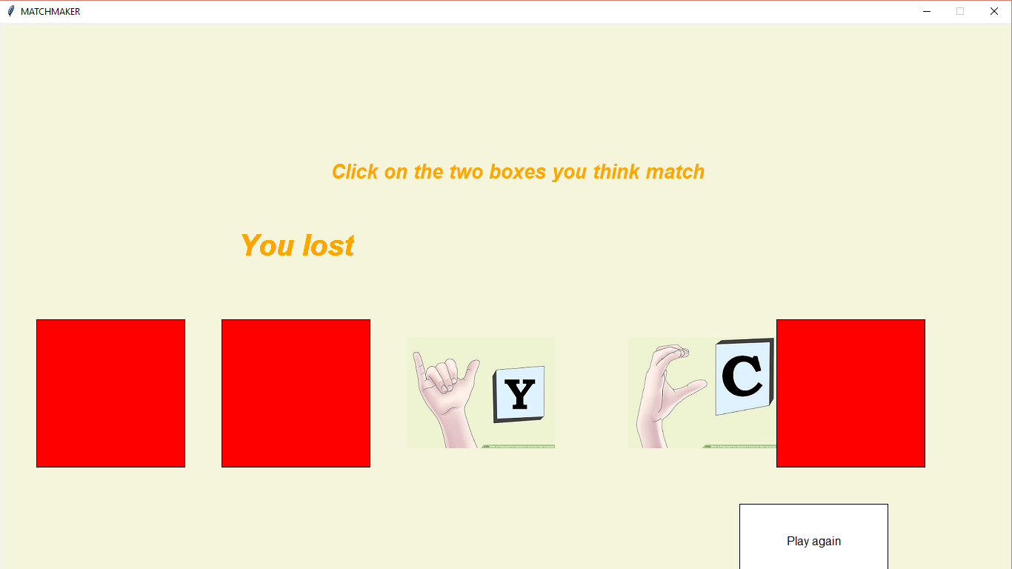

Figure

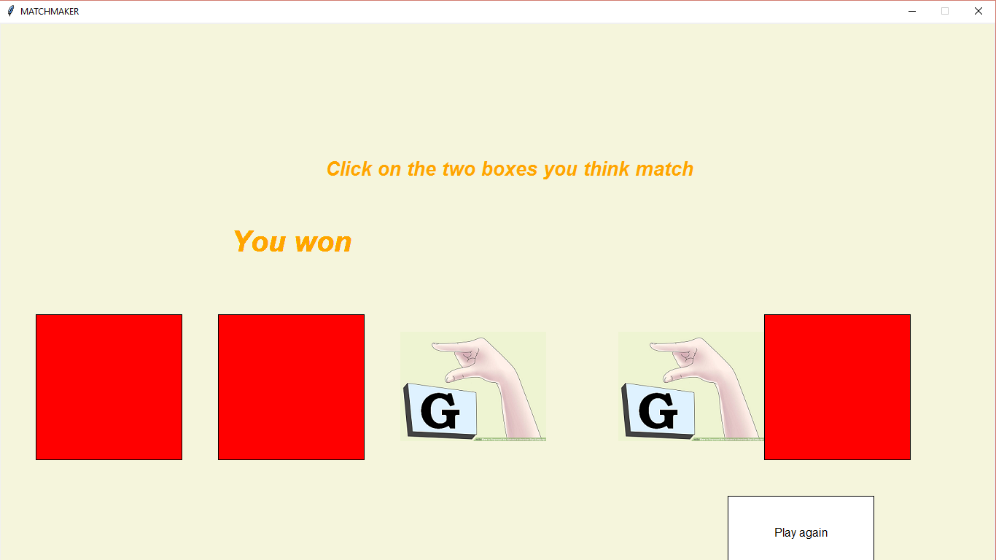

Figure

After the boxes have been clicked, the images are displayed and a message is drawn showing whether the game was won or lost. As shown in Figures 4 & 5 above.

**CONCLUSION**

At the end of playing the “Matchmaker”, the user is able to effectively differentiate between the sign language representation of the English alphabets and also to interact well and effectively communicate with deaf and dumb individuals.

**APPENDIX**

from graphics import*

from random import randrange

class Project:

def __init__(self):

pass

#this function draws the graphical user interface

def start_game(self, win,atl):

win.setCoords(0.0,0.0,15.0,8.0)

win.setBackground("beige")

wi = Text(Point(7,7),"Welcome to THE MATCHMAKER!!")

wi.setStyle("bold italic")

wi.setFill("orange")

wi.setSize(20)

wi.draw(win)

wit = Text(Point(7,6),"This game is a fun way to learn sign language!")

wit.setStyle("bold italic")

wit.setFill("orange")

wit.setSize(20)

wit.draw(win)

wit1 = Text(Point(7,5),"Click anywhere to start")

wit1.setStyle("bold italic")

wit1.setFill("orange")

wit1.setSize(20)

wit1.draw(win)

win.getMouse()

wit.undraw()

wit1.undraw()

wi.setText("There will be 5 boxes drawn in the window")

atl.setStyle("bold italic")

atl.setFill("orange")

atl.setSize(20)

atl.draw(win)

wo = Text(Point(7,5), "Click anywhere to start")

wo.setStyle("bold italic")

wo.setFill("orange")

wo.setSize(20)

wo.draw(win)

win.getMouse()

wi.setText("")

atl.setText("")

wo.setText("")

atl.setText("Click on the two boxes you think match!!!")

def draw_rectangles(self,win,atl):

un = Rectangle(Point(0.5,2),Point(2.5,4))

un.setFill("red")

un.setOutline("black")

un2 = un.clone()

un2.move(2.5,0)

un.draw(win)

un2.draw(win)

un3 = un2.clone()

un3.move(2.5,0)

un3.draw(win)

un4 = un3.clone()

un4.move(2.5,0)

un4.draw(win)

un5 = un4.clone()

un5.move(2.5,0)

un5.draw(win)

##alpha randomly picks between 1 - 26 to represent the 26 english alphabets

##when either of them is chosen it draws two of the correspnding letters when

##clicked and 3 other letters

alpha = randrange(1,27)

print(alpha)

if alpha == 1:

ty = win.getMouse()

i1 = ty.getX()

e1 = ty.getY()

if 0.5<= i1<=2.5 and 2<= e1<=4:

r = 'a'

at = Image(Point(1,3),"A.png")

at.draw(win)

un.undraw()

if 3 <= i1 <= 5 and 2<= e1<= 4:

r1 = 'a'

at1 = Image(Point(3.5,3),"A.png")

at1.draw(win)

un2.undraw()

if 5.5 <= i1 <= 7.5 and 2 <= e1 <=4:

r2 = 't'

at2 = Image(Point(6.5,3),"T.png")

at2.draw(win)

un3.undraw()

if 8<= i1 <= 10 and 2 <=e1 <= 4:

r3 = 'x'

at3 = Image(Point(9.5,3),"X.png")

at3.draw(win)

un4.undraw()

if 10.5 <= i1 <= 12.5 and 2 <= e1 <= 4:

r4='y'

at4 = Image(Point(12.5,3),"Y.png")

at4.draw(win)

un5.undraw()

ty2 = win.getMouse()

i2 = ty2.getX()

e2 = ty2.getY()

if 0.5<= i2<=2.5 and 2<= e2<=4:

r = 'a'

at = Image(Point(1,3),"A.png")

at.draw(win)

un.undraw()

if 3 <= i2 <= 5 and 2<= e2<= 4:

r1 = 'a'

at1 = Image(Point(3.5,3),"A.png")

at1.draw(win)

un2.undraw()

if 5.5 <= i2 <= 7.5 and 2 <= e2 <=4:

r2 = 't'

at2 = Image(Point(6.5,3),"T.png")

at2.draw(win)

un3.undraw()

if 8<= i2 <= 10 and 2 <=e2 <= 4:

r3 = 'x'

at3 = Image(Point(9.5,3),"X.png")

at3.draw(win)

un4.undraw()

if 10.5 <= i2 <= 12.5 and 2 <= e2 <= 4:

r4='y'

at4 = Image(Point(12.5,3),"Y.png")

at4.draw(win)

un5.undraw()

#this for loop checks for matches between the two boxes selected

for i in range (100):

atl.undraw()

if 0.5<= i1<=2.5 and 2<= e1<=4:

if 3 <= i2 <= 5 and 2<= e2<= 4:

if r == r1:

wins = Text(Point(4,5),"You won")

wins.setStyle("bold italic")

wins.setFill("orange")

wins.setSize(30)

wins.draw(win)

elif 3<= i1<=5 and 2<= e1<=4:

if 0.5 <= i2 <= 2.5 and 2<= e2<= 4:

if r1 == r:

wins = Text(Point(4,5),"You won")

wins.setStyle("bold italic")

wins.setFill("orange")

wins.setSize(30)

wins.draw(win)

else:

atl.undraw()

lose = Text(Point(4,5),"You lost")

lose.setStyle("bold italic")

lose.setFill("orange")

lose.setSize(30)

lose.draw(win)

elif alpha == 2:

ty = win.getMouse()

i1 = ty.getX()

e1 = ty.getY()

if 0.5<= i1<=2.5 and 2<= e1<=4:

r = 'b'

an = Image(Point(1,3), "B.png")

an.draw(win)

un.undraw()

if 3 <= i1 <= 5 and 2<= e1<= 4:

r1 = 'c'

an1 = Image(Point(3.5,3), "C.png")

an1.draw(win)

un2.undraw()

if 5.5 <= i1 <= 7.5 and 2 <= e1 <=4:

r2 = 'z'

an2 = Image(Point(6.5,3), "Z.png")

an2.draw(win)

un3.undraw()

if 8<= i1 <= 10 and 2 <=e1 <= 4:

r3 = 'b'

an3 = Image(Point(9.5,3), "B.png")

an3.draw(win)

un4.undraw()

if 10.5 <= i1 <= 12.5 and 2 <= e1 <= 4:

r4 = 'f'

an4 = Image(Point(12.5,3), "F.png")

an4.draw(win)

un5.undraw()

ty2 = win.getMouse()

i2 = ty2.getX()

e2 = ty2.getY()

if 0.5<= i2<=2.5 and 2<= e2<=4:

r = 'b'

an = Image(Point(1,3), "B.png")

an.draw(win)

un.undraw()

if 3 <= i2 <= 5 and 2<= e2<= 4:

r1 = 'c'

an1 = Image(Point(3.5,3), "C.png")

an1.draw(win)

un2.undraw()

if 5.5 <= i2 <= 7.5 and 2 <= e2 <=4:

r2 = 'z'

an2 = Image(Point(6.5,3), "Z.png")

an2.draw(win)

un3.undraw()

if 8<= i2 <= 10 and 2 <=e2 <= 4:

r3 = 'b'

an3 = Image(Point(9.5,3), "B.png")

an3.draw(win)

un4.undraw()

if 10.5 <= i2 <= 12.5 and 2 <= e2 <= 4:

r4 = 'f'

an4 = Image(Point(12.5,3), "F.png")

an4.draw(win)

un5.undraw()

for i in range (100):

atl.undraw()

if 0.5<= i1<=2.5 and 2<= e1<=4:

if 8<= i2 <= 10 and 2 <=e2 <= 4:

if r == r3:

atl.undraw()

wins = Text(Point(4,5),"You won")

wins.setStyle("bold italic")

wins.setFill("orange")

wins.setSize(30)

wins.draw(win)

elif 8<= i1<=10 and 2<= e1<=4:

if 0.5<= i2 <= 2.5 and 2 <=e2 <= 4:

if r3 == r:

atl.undraw()

wins = Text(Point(4,5),"You won")

wins.setStyle("bold italic")

wins.setFill("orange")

wins.setSize(30)

wins.draw(win)

else:

atl.undraw()

lose = Text(Point(4,5),"You lost")

lose.setStyle("bold italic")

lose.setFill("orange")

lose.setSize(30)

lose.draw(win)

elif alpha == 3:

ty = win.getMouse()

i1 = ty.getX()

e1 = ty.getY()

if 0.5<= i1<=2.5 and 2<= e1<=4:

r = 'x'

ad = Image(Point(1,3),"X.png")

ad.draw(win)

un.undraw()

if 3 <= i1 <= 5 and 2<= e1<= 4:

r1 = 'd'

ad1 = Image(Point(3.5,3),"D.png")

ad1.draw(win)

un2.undraw()

if 5.5 <= i1<= 7.5 and 2 <= e1 <=4:

r2 = 'y'

ad2 = Image(Point(6.5,3),"Y.png")

ad2.draw(win)

un3.undraw()

if 8<= i1 <= 10 and 2 <=e1 <= 4:

r3 = 'c'

ad3 = Image(Point(9.5,3),"C.png")

ad3.draw(win)

un4.undraw()

if 10.5 <= i1 <= 12.5 and 2 <= e1 <= 4:

r4 = 'c'

ad4 = Image(Point(12.5,3),"C.png")

ad4.draw(win)

un5.undraw()

ty2 = win.getMouse()

i2 = ty2.getX()

e2 = ty2.getY()

if 0.5<= i2<=2.5 and 2<= e2<=4:

r = 'x'

ad = Image(Point(1,3),"X.png")

ad.draw(win)

un.undraw()

if 3 <= i2 <= 5 and 2<= e2<= 4:

r1 = 'd'

ad1 = Image(Point(3.5,3),"D.png")

ad1.draw(win)

un2.undraw()

if 5.5 <= i2<= 7.5 and 2 <= e2<=4:

r2 = 'y'

ad2 = Image(Point(6.5,3),"Y.png")

ad2.draw(win)

un3.undraw()

if 8<= i2 <= 10 and 2 <=e2 <= 4:

r3 = 'c'

ad3 = Image(Point(9.5,3),"C.png")

ad3.draw(win)

un4.undraw()

if 10.5 <= i2 <= 12.5 and 2 <= e2 <= 4:

r4 = 'c'

ad4 = Image(Point(12.5,3),"C.png")

ad4.draw(win)

un5.undraw()

for i in range (100):

atl.undraw()

if 8<= i1 <= 10 and 2 <=e1 <= 4:

if 10.5 <= i2 <= 12.5 and 2 <= e2 <= 4:

if r3 == r4 :

atl.undraw()

wins = Text(Point(4,5),"You won")

wins.setStyle("bold italic")

wins.setFill("orange")

wins.setSize(30)

wins.draw(win)

elif 10.5<= i1 <= 12.5 and 2 <=e1 <= 4:

if 8 <= i2 <= 10 and 2 <= e2 <= 4:

if r4 == r3 :

atl.undraw()

wins = Text(Point(4,5),"You won")

wins.setStyle("bold italic")

wins.setFill("orange")

wins.setSize(30)

wins.draw(win)

else:

atl.undraw()

lose = Text(Point(4,5),"You lost")

lose.setStyle("bold italic")

lose.setFill("orange")

lose.setSize(30)

lose.draw(win)

elif alpha == 4:

ty = win.getMouse()

i1 = ty.getX()

e1 = ty.getY()

if 0.5<= i1<=2.5 and 2<= e1<=4:

r = 'x'

ade = Image(Point(1,3),"X.png")

ade.draw(win)

un.undraw()

if 3 <= i1 <= 5 and 2<= e1<= 4:

r1 = 'd'

ade1 = Image(Point(3.5,3),"D.png")

ade1.draw(win)

un2.undraw()

if 5.5 <= i1 <= 7.5 and 2 <= e1 <=4:

r2 = 'd'

ade2 = Image(Point(6.5,3),"D.png")

ade2.draw(win)

un3.undraw()

if 8<= i1 <= 10 and 2 <=e1 <= 4:

r3 = 'c'

ade3 = Image(Point(9.5,3),"C.png")

ade3.draw(win)

un4.undraw()

if 10.5 <= i1 <= 12.5 and 2 <= e1 <= 4:

r4 = 'e'

ade4 = Image(Point(12.5,3),"E.png")

ade4.draw(win)

un5.undraw()

ty2 = win.getMouse()

i2 = ty2.getX()

e2 = ty2.getY()

if 0.5<= i2<=2.5 and 2<= e2<=4:

r = 'x'

ade = Image(Point(1,3),"X.png")

ade.draw(win)

un.undraw()

if 3 <= i2 <= 5 and 2<= e2<= 4:

r1 = 'd'

ade1 = Image(Point(3.5,3),"D.png")

ade1.draw(win)

un2.undraw()

if 5.5 <= i2 <= 7.5 and 2 <= e2 <=4:

r2 = 'd'

ade2 = Image(Point(6.5,3),"D.png")

ade2.draw(win)

un3.undraw()

if 8<= i2 <= 10 and 2 <=e2 <= 4:

r3 = 'c'

ade3 = Image(Point(9.5,3),"C.png")

ade3.draw(win)

un4.undraw()

if 10.5 <= i2 <= 12.5 and 2 <= e2 <= 4:

r4 = 'e'

ade4 = Image(Point(12.5,3),"E.png")

ade4.draw(win)

un5.undraw()

for i in range (100):

atl.undraw()

if 3 <= i1 <= 5 and 2<= e1<= 4:

if 5.5 <= i2 <= 7.5 and 2 <= e2 <=4:

if r1 == r2:

wins = Text(Point(4,5),"You won")

wins.setStyle("bold italic")

wins.setFill("orange")

wins.setSize(30)

wins.draw(win)

elif 5.5 <= i1 <= 7.5 and 2<= e1<= 4:

if 3 <= i2 <= 5 and 2 <= e2 <=4:

if r2 == r1:

wins = Text(Point(4,5),"You won")

wins.setStyle("bold italic")

wins.setFill("orange")

wins.setSize(30)

wins.draw(win)

else:

atl.undraw()

lose = Text(Point(4,5),"You lost")

lose.setStyle("bold italic")

lose.setFill("orange")

lose.setSize(30)

lose.draw(win)

elif alpha == 5:

ty = win.getMouse()

i1 = ty.getX()

e1 = ty.getY()

if 0.5<= i1<=2.5 and 2<= e1<=4:

r='e'

ado = Image(Point(1,3),"E.png")

ado.draw(win)

un.undraw()

if 3 <= i1 <= 5 and 2<= e1<= 4:

r1='d'

ado1 = Image(Point(3.5,3),"D.png")

ado1.draw(win)

un2.undraw()

if 5.5 <= i1 <= 7.5 and 2 <= e1 <=4:

r2='y'

ado2 = Image(Point(6.5,3),"Y.png")

ado2.draw(win)

un3.undraw()

if 8<= i1 <= 10 and 2 <=e1 <= 4:

r3='e'

ado3 = Image(Point(9.5,3),"E.png")

ado3.draw(win)

un4.undraw()

if 10.5 <= i1 <= 12.5 and 2 <= e1 <= 4:

r4='c'

ado4 = Image(Point(12.5,3),"C.png")

ado4.draw(win)

un5.undraw()

ty2 = win.getMouse()

i2 = ty2.getX()

e2 = ty2.getY()

if 0.5<= i2<=2.5 and 2<= e2<=4:

r='e'

ado = Image(Point(1,3),"E.png")

ado.draw(win)

un.undraw()

if 3 <= i2 <= 5 and 2<= e2<= 4:

r1='d'

ado1 = Image(Point(3.5,3),"D.png")

ado1.draw(win)

un2.undraw()

if 5.5 <= i2 <= 7.5 and 2 <= e2 <=4:

r2='y'

ado2 = Image(Point(6.5,3),"Y.png")

ado2.draw(win)

un3.undraw()

if 8<= i2 <= 10 and 2 <=e2 <= 4:

r3='e'

ado3 = Image(Point(9.5,3),"E.png")

ado3.draw(win)

un4.undraw()

if 10.5 <= i2 <= 12.5 and 2 <= e2 <= 4:

r4='c'

ado4 = Image(Point(12.5,3),"C.png")

ado4.draw(win)

un5.undraw()

for i in range (100):

atl.undraw()

if 0.5<= i1<=2.5 and 2<= e1<=4:

if 8 <= i2 <= 10 and 2<= e2<= 4:

if r == r3:

wins = Text(Point(4,5),"You won")

wins.setStyle("bold italic")

wins.setFill("orange")

wins.setSize(30)

wins.draw(win)

elif 8<= i1<=10 and 2<= e1<=4:

if 0.5 <= i2 <= 2.5 and 2<= e2<= 4:

if r3 == r:

wins = Text(Point(4,5),"You won")

wins.setStyle("bold italic")

wins.setFill("orange")

wins.setSize(30)

wins.draw(win)

else:

atl.undraw()

lose = Text(Point(4,5),"You lost")

lose.setStyle("bold italic")

lose.setFill("orange")

lose.setSize(30)

lose.draw(win)

elif alpha == 6:

ty = win.getMouse()

i1 = ty.getX()

e1 = ty.getY()

if 0.5<= i1<=2.5 and 2<= e1<=4:

r='x'

adi = Image(Point(1,3),"X.png")

adi.draw(win)

un.undraw()

if 3 <= i1 <= 5 and 2<= e1<= 4:

r1='f'

adi1 = Image(Point(3.5,3),"F.png")

adi1.draw(win)

un2.undraw()

if 5.5 <= i1 <= 7.5 and 2 <= e1 <=4:

r2='f'

adi2 = Image(Point(6.5,3),"F.png")

adi2.draw(win)

un3.undraw()

if 8<= i1 <= 10 and 2 <=e1 <= 4:

r3='s'

adi3 = Image(Point(9.5,3),"S.png")

adi3.draw(win)

un4.undraw()

if 10.5 <= i1 <= 12.5 and 2 <= e1 <= 4:

r4='i'

adi4 = Image(Point(12.5,3),"I.png")

adi4.draw(win)

un5.undraw()

ty2 = win.getMouse()

i2 = ty2.getX()

e2 = ty2.getY()

if 0.5<= i2<=2.5 and 2<= e2<=4:

r='x'

adi = Image(Point(1,3),"X.png")

adi.draw(win)

un.undraw()

if 3 <= i2 <= 5 and 2<= e2<= 4:

r1='f'

adi1 = Image(Point(3.5,3),"F.png")

adi1.draw(win)

un2.undraw()

if 5.5 <= i2 <= 7.5 and 2 <= e2 <=4:

r2='f'

adi2 = Image(Point(6.5,3),"F.png")

adi2.draw(win)

un3.undraw()

if 8<= i2 <= 10 and 2 <=e2 <= 4:

r3='s'

adi3 = Image(Point(9.5,3),"S.png")

adi3.draw(win)

un4.undraw()

if 10.5 <= i2 <= 12.5 and 2 <= e2 <= 4:

r4='i'

adi4 = Image(Point(12.5,3),"I.png")

adi4.draw(win)

un5.undraw()

for i in range (100):

atl.undraw()

if 3<= i1<=5 and 2<= e1<=4:

if 5.5 <= i2 <= 7.5 and 2<= e2<= 4:

if r1 == r2:

wins = Text(Point(4,5),"You won")

wins.setStyle("bold italic")

wins.setFill("orange")

wins.setSize(30)

wins.draw(win)

elif 5.5<= i1<=7.5 and 2<= e1<=4:

if 3 <= i2 <= 5 and 2<= e2<= 4:

if r2 == r1:

wins = Text(Point(4,5),"You won")

wins.setStyle("bold italic")

wins.setFill("orange")

wins.setSize(30)

wins.draw(win)

else:

atl.undraw()

lose = Text(Point(4,5),"You lost")

lose.setStyle("bold italic")

lose.setFill("orange")

lose.setSize(30)

lose.draw(win)

elif alpha == 7:

ty = win.getMouse()

i1 = ty.getX()

e1 = ty.getY()

if 0.5<= i1<=2.5 and 2<= e1<=4:

r='g'

ap = Image(Point(1,3),"G.png")

ap.draw(win)

un.undraw()

if 3 <= i1 <= 5 and 2<= e1<= 4:

r1='g'

ap1 = Image(Point(3.5,3),"G.png")

ap1.draw(win)

un2.undraw()

if 5.5 <= i1 <= 7.5 and 2 <= e1 <=4:

r2='g'

ap2 = Image(Point(6.5,3),"G.png")

ap2.draw(win)

un3.undraw()

if 8<= i1 <= 10 and 2 <=e1 <= 4:

r3='g'

ap3 = Image(Point(9.5,3),"G.png")

ap3.draw(win)

un4.undraw()

if 10.5 <= i1 <= 12.5 and 2 <= e1 <= 4:

r4='g'

ap4 = Image(Point(12.5,3),"G.png")

ap4.draw(win)

un5.undraw()

ty2 = win.getMouse()

i2 = ty2.getX()

e2 = ty2.getY()

if 0.5<= i2<=2.5 and 2<= e2<=4:

r='g'

ap = Image(Point(1,3),"G.png")

ap.draw(win)

un.undraw()

if 3 <= i2 <= 5 and 2<= e2<= 4:

r1='g'

ap1 = Image(Point(3.5,3),"G.png")

ap1.draw(win)

un2.undraw()

if 5.5 <= i2 <= 7.5 and 2 <= e2 <=4:

r2='g'

ap2 = Image(Point(6.5,3),"G.png")

ap2.draw(win)

un3.undraw()

if 8<= i2<= 10 and 2 <=e2 <= 4:

r3='g'

ap3 = Image(Point(9.5,3),"G.png")

ap3.draw(win)

un4.undraw()

if 10.5 <= i2 <= 12.5 and 2 <= e2 <= 4:

r4='g'

ap4 = Image(Point(12.5,3),"G.png")

ap4.draw(win)

un5.undraw()

for i in range (100):

atl.undraw()

if 0.5<= i1<=2.5 and 2<= e1<=4:

if 3 <= i2 <= 5 and 2<= e2<= 4:

if r == r1:

wins = Text(Point(4,5),"You won")

wins.setStyle("bold italic")

wins.setFill("orange")

wins.setSize(30)

wins.draw(win)

elif 3<= i1<=5 and 2<= e1<=4:

if 0.5 <= i2 <= 2.5 and 2<= e2<= 4:

if r1 == r:

wins = Text(Point(4,5),"You won")

wins.setStyle("bold italic")

wins.setFill("orange")

wins.setSize(30)

wins.draw(win)

else:

atl.undraw()

lose = Text(Point(4,5),"You won")

lose.setStyle("bold italic")

lose.setFill("orange")

lose.setSize(30)

lose.draw(win)

elif alpha == 8:

ty = win.getMouse()

i1 = ty.getX()

e1 = ty.getY()

if 0.5<= i1<=2.5 and 2<= e1<=4:

r='t'

ape = Image(Point(0.5,3),"T.png")

ape.draw(win)

un.undraw()

if 3 <= i1 <= 5 and 2<= e1<= 4:

r1='d'

ape1 = Image(Point(3.5,3),"D.png")

ape1.draw(win)

un2.undraw()

if 5.5 <= i1 <= 7.5 and 2 <= e1 <=4:

r2='h'

ape2 = Image(Point(6.5,3),"H.png")

ape2.draw(win)

un3.undraw()

if 8<= i1 <= 10 and 2 <=e1 <= 4:

r3='h'

ape3 = Image(Point(9.5,3),"H.png")

ape3.draw(win)

un4.undraw()

if 10.5 <= i1 <= 12.5 and 2 <= e1 <= 4:

r4='l'

ape4 = Image(Point(12.5,3),"L.png")

ape4.draw(win)

un5.undraw()

ty2 = win.getMouse()

i2 = ty2.getX()

e2 = ty2.getY()

if 0.5<= i2<=2.5 and 2<= e2<=4:

r='t'

ape = Image(Point(0.5,3),"T.png")

ape.draw(win)

un.undraw()

if 3 <= i2 <= 5 and 2<= e2<= 4:

r1='d'

ape1 = Image(Point(3.5,3),"D.png")

ape1.draw(win)

un2.undraw()

if 5.5 <= i2 <= 7.5 and 2 <= e2 <=4:

r2='h'

ape2 = Image(Point(6.5,3),"H.png")

ape2.draw(win)

un3.undraw()

if 8<= i2 <= 10 and 2 <=e2 <= 4:

r3='h'

ape3 = Image(Point(9.5,3),"H.png")

ape3.draw(win)

un4.undraw()

if 10.5 <= i2 <= 12.5 and 2 <= e2 <= 4:

r4='l'

ape4 = Image(Point(12.5,3),"L.png")

ape4.draw(win)

un5.undraw()

for i in range (100):

atl.undraw()

if 5.5<= i1<=7.5 and 2<= e1<=4:

if 8 <= i2 <= 10 and 2<= e2<= 4:

if r2 == r3:

wins = Text(Point(4,5),"You won")

wins.setStyle("bold italic")

wins.setFill("orange")

wins.setSize(30)

wins.draw(win)

if 8<= i1<=10 and 2<= e1<=4:

if 5.5 <= i2 <= 7.5 and 2<= e2<= 4:

if r3 == r2:

wins = Text(Point(4,5),"You won")

wins.setStyle("bold italic")

wins.setFill("orange")

wins.setSize(30)

wins.draw(win)

else:

atl.undraw()

lose = Text(Point(4,5),"You lost")

lose.setStyle("bold italic")

lose.setFill("orange")

lose.setSize(30)

lose.draw(win)

elif alpha == 9:

ty = win.getMouse()

i1 = ty.getX()

e1 = ty.getY()

if 0.5<= i1<=2.5 and 2<= e1<=4:

r='x'

af = Image(Point(1,3),"X.png")

af.draw(win)

un.undraw()

if 3 <= i1 <= 5 and 2<= e1<= 4:

r1='d'

af1 = Image(Point(3.5,3),"D.png")

af1.draw(win)

un2.undraw()

if 5.5 <= i1 <= 7.5 and 2 <= e1 <=4:

r2='y'

af2 = Image(Point(6.5,3),"Y.png")

af2.draw(win)

un3.undraw()

if 8<= i1 <= 10 and 2 <=e1 <= 4:

r3='i'

af3 = Image(Point(9.5,3),"I.png")

af3.draw(win)

un4.undraw()

if 10.5 <= i1 <= 12.5 and 2 <= e1 <= 4:

r4='i'

af4 = Image(Point(12.5,3),"I.png")

af4.draw(win)

un5.undraw()

ty2 = win.getMouse()

i2 = ty2.getX()

e2 = ty2.getY()

if 0.5<= i2<=2.5 and 2<= e2<=4:

r='x'

af = Image(Point(1,3),"X.png")

af.draw(win)

un.undraw()

if 3 <= i2 <= 5 and 2<= e2<= 4:

r1='d'

af1 = Image(Point(3.5,3),"D.png")

af1.draw(win)

un2.undraw()

if 5.5 <= i2 <= 7.5 and 2 <= e2 <=4:

r2='y'

af2 = Image(Point(6.5,3),"Y.png")

af2.draw(win)

un3.undraw()

if 8<= i2 <= 10 and 2 <=e2 <= 4:

r3='i'

af3 = Image(Point(9.5,3),"I.png")

af3.draw(win)

un4.undraw()

if 10.5 <= i2 <= 12.5 and 2 <= e2 <= 4:

r4='i'

af4 = Image(Point(12.5,3),"I.png")

af4.draw(win)

un5.undraw()

for i in range (100):

atl.undraw()

if 8<= i1<=10 and 2<= e1<=4:

if 10.5 <= i2 <= 12.5 and 2<= e2<= 4:

if r3 == r4:

wins = Text(Point(4,5),"You won")

wins.setStyle("bold italic")

wins.setFill("orange")

wins.setSize(30)

wins.draw(win)

elif 10.5<= i1<=12.5 and 2<= e1<=4:

if 8 <= i2 <= 10 and 2<= e2<= 4:

if r4 == r3:

wins = Text(Point(4,5),"You won")

wins.setStyle("bold italic")

wins.setFill("orange")

wins.setSize(30)

wins.draw(win)

else:

atl.undraw()

lose = Text(Point(4,5),"You lost")

lose.setStyle("bold italic")

lose.setFill("orange")

lose.setSize(30)

lose.draw(win)

elif alpha == 10:

ty = win.getMouse()

i1 = ty.getX()

e1 = ty.getY()

if 0.5<= i1<=2.5 and 2<= e1<=4:

r='p'

ano = Image(Point(1,3), "P.png")

ano.draw(win)

un.undraw()

if 3 <= i1 <= 5 and 2<= e1<= 4:

r1='j'

ano1 = Image(Point(3.5,3), "J.png")

ano1.draw(win)

un2.undraw()

if 5.5 <= i1 <= 7.5 and 2 <= e1 <=4:

r2='z'

ano2 = Image(Point(6.5,3), "Z.png")

ano2.draw(win)

un3.undraw()

if 8<= i1 <= 10 and 2 <=e1 <= 4:

r3='u'

ano3 = Image(Point(9.5,3), "U.png")

ano3.draw(win)

un4.undraw()

if 10.5 <= i1 <= 12.5 and 2 <= e1 <= 4:

r4='j'

ano4 = Image(Point(12.5,3), "J.png")

ano4.draw(win)

un5.undraw()

ty2 = win.getMouse()

i2 = ty2.getX()

e2 = ty2.getY()

if 0.5<= i2<=2.5 and 2<= e2<=4:

r='p'

ano = Image(Point(1,3), "P.png")

ano.draw(win)

un.undraw()

if 3 <= i2 <= 5 and 2<= e2<= 4:

r1='j'

ano1 = Image(Point(3.5,3), "J.png")

ano1.draw(win)

un2.undraw()

if 5.5 <= i2 <= 7.5 and 2 <= e2<=4:

r2='z'

ano2 = Image(Point(6.5,3), "Z.png")

ano2.draw(win)

un3.undraw()

if 8<= i2 <= 10 and 2 <=e2 <= 4:

r3='u'

ano3 = Image(Point(9.5,3), "U.png")

ano3.draw(win)

un4.undraw()

if 10.5 <= i2 <= 12.5 and 2 <= e2 <= 4:

r4='j'

ano4 = Image(Point(12.5,3), "J.png")

ano4.draw(win)

un5.undraw()

for i in range (100):

atl.undraw()

if 3<= i1<=5 and 2<= e1<=4:

if 10.5 <= i2 <= 12.5 and 2<= e2<= 4:

if r1 == r4:

wins = Text(Point(4,5),"You won")

wins.setStyle("bold italic")

wins.setFill("orange")

wins.setSize(30)

wins.draw(win)

elif 10.5<= i1<=12.5 and 2<= e1<=4:

if 3 <= i2 <= 5 and 2<= e2<= 4:

if r4 == r1:

wins = Text(Point(4,5),"You won")

wins.setStyle("bold italic")

wins.setFill("orange")

wins.setSize(30)

wins.draw(win)

else:

atl.undraw()

lose = Text(Point(4,5),"You lost")

lose.setStyle("bold italic")

lose.setFill("orange")

lose.setSize(30)

lose.draw(win)

elif alpha == 11:

ty = win.getMouse()

i1 = ty.getX()

e1 = ty.getY()

if 0.5<= i1<=2.5 and 2<= e1<=4:

r='o'

att = Image(Point(1,3),"O.png")

att.draw(win)

un.undraw()

if 3 <= i1 <= 5 and 2<= e1<= 4:

r1='z'

att1 = Image(Point(3.5,3),"Z.png")

att1.draw(win)

un2.undraw()

if 5.5 <= i1 <= 7.5 and 2 <= e1 <=4:

r2='n'

att2 = Image(Point(6.5,3),"N.png")

att2.draw(win)

un3.undraw()

if 8<= i1 <= 10 and 2 <=e1 <= 4:

r3='k'

att3 = Image(Point(9.5,3),"K.png")

att3.draw(win)

un4.undraw()

if 10.5 <= i1 <= 12.5 and 2 <= e1 <= 4:

r4='k'

att4 = Image(Point(12.5,3),"K.png")

att4.draw(win)

un5.undraw()

ty2 = win.getMouse()

i2 = ty2.getX()

e2 = ty2.getY()

if 0.5<= i2<=2.5 and 2<= e2<=4:

r='o'

att = Image(Point(1,3),"O.png")

att.draw(win)

un.undraw()

if 3 <= i2 <= 5 and 2<= e2<= 4:

r1='z'

att1 = Image(Point(3.5,3),"Z.png")

att1.draw(win)

un2.undraw()

if 5.5 <= i2 <= 7.5 and 2 <= e2 <=4:

r2='n'

att2 = Image(Point(6.5,3),"N.png")

att2.draw(win)

un3.undraw()

if 8<= i2 <= 10 and 2 <=e2 <= 4:

r3='k'

att3 = Image(Point(9.5,3),"K.png")

att3.draw(win)

un4.undraw()

if 10.5 <= i2 <= 12.5 and 2 <= e2 <= 4:

r4='k'

att4 = Image(Point(12.5,3),"K.png")

att4.draw(win)

un5.undraw()

for i in range (100):

atl.undraw()

if 8<= i1<=10 and 2<= e1<=4:

if 10.5<= i2 <= 12.5 and 2<= e2<= 4:

if r3 == r4:

wins = Text(Point(4,5),"You won")

wins.setStyle("bold italic")

wins.setFill("orange")

wins.setSize(30)

wins.draw(win)

if 10.5<= i1<=12.5 and 2<= e1<=4:

if 8<= i2 <= 10 and 2<= e2<= 4:

if r4 == r3:

wins = Text(Point(4,5),"You won")

wins.setStyle("bold italic")

wins.setFill("orange")

wins.setSize(30)

wins.draw(win)

else:

atl.undraw()

lose = Text(Point(4,5),"You lost")

lose.setStyle("bold italic")

lose.setFill("orange")

lose.setSize(30)

lose.draw(win)

elif alpha == 12:

ty = win.getMouse()

i1 = ty.getX()

e1 = ty.getY()

if 0.5<= i1<=2.5 and 2<= e1<=4:

r='t'

aden = Image(Point(1,3),"T.png")

aden.draw(win)

un.undraw()

if 3 <= i1 <= 5 and 2<= e1<= 4:

r1='l'

aden1 = Image(Point(3.5,3),"L.png")

aden1.draw(win)

un2.undraw()

if 5.5 <= i1 <= 7.5 and 2 <= e1 <=4:

r2='l'

aden2 = Image(Point(6.5,3),"L.png")

aden2.draw(win)

un3.undraw()

if 8<= i1 <= 10 and 2 <=e1 <= 4:

r3='c'

aden3 = Image(Point(9.5,3),"C.png")

aden3.draw(win)

un4.undraw()

if 10.5 <= i1 <= 12.5 and 2 <= e1 <= 4:

r4='e'

aden4 = Image(Point(12.5,3),"E.png")

aden4.draw(win)

un5.undraw()

ty2 = win.getMouse()

i2 = ty2.getX()

e2 = ty2.getY()

if 0.5<= i2<=2.5 and 2<= e2<=4:

r='t'

aden = Image(Point(1,3),"T.png")

aden.draw(win)

un.undraw()

if 3 <= i2 <= 5 and 2<= e2<= 4:

r1='l'

aden1 = Image(Point(3.5,3),"L.png")

aden1.draw(win)

un2.undraw()

if 5.5 <= i2 <= 7.5 and 2 <= e2 <=4:

r2='l'

aden2 = Image(Point(6.5,3),"L.png")

aden2.draw(win)

un3.undraw()

if 8<= i2 <= 10 and 2 <=e2 <= 4:

r3='c'

aden3 = Image(Point(9.5,3),"C.png")

aden3.draw(win)

un4.undraw()

if 10.5 <= i2 <= 12.5 and 2 <= e2 <= 4:

r4='e'

aden4 = Image(Point(12.5,3),"E.png")

aden4.draw(win)

un5.undraw()

for i in range (100):

atl.undraw()

if 3 <= i1<=5 and 2<= e1<=4:

if 5.5<= i2 <= 7.5 and 2<= e2<= 4:

if r1 == r2:

wins = Text(Point(4,5),"You won")

wins.setStyle("bold italic")

wins.setFill("orange")

wins.setSize(30)

wins.draw(win)

elif 5.5<= i1<=7.5 and 2<= e1<=4:

if 3<= i2 <= 5 and 2<= e2<= 4:

if r2 == r1:

wins = Text(Point(4,5),"You won")

wins.setStyle("bold italic")

wins.setFill("orange")

wins.setSize(30)

wins.draw(win)

else:

atl.undraw()

lose = Text(Point(4,5),"You lost")

lose.setStyle("bold italic")

lose.setFill("orange")

lose.setSize(30)

lose.draw(win)

elif alpha == 13:

ty = win.getMouse()

i1 = ty.getX()

e1 = ty.getY()

if 0.5<= i1<=2.5 and 2<= e1<=4:

r='m'

ani = Image(Point(0.5,3), "M.png")

ani.draw(win)

un.undraw()

if 3 <= i1 <= 5 and 2<= e1<= 4:

r1='c'

ani1 = Image(Point(3.5,3), "C.png")

ani1.draw(win)

un2.undraw()

if 5.5 <= i1 <= 7.5 and 2 <= e1 <=4:

r2='z'

ani2 = Image(Point(6.5,3), "Z.png")

ani2.draw(win)

un3.undraw()

if 8<= i1 <= 10 and 2 <=e1 <= 4:

r3='m'

ani3 = Image(Point(9.5,3), "M.png")

ani3.draw(win)

un4.undraw()

if 10.5 <= i1 <= 12.5 and 2 <= e1 <= 4:

r4='f'

ani4 = Image(Point(12.5,3), "F.png")

ani4.draw(win)

un5.undraw()

ty2 = win.getMouse()

i2 = ty2.getX()

e2 = ty2.getY()

if 0.5<= i2<=2.5 and 2<= e2<=4:

r='m'

ani = Image(Point(0.5,3), "M.png")

ani.draw(win)

un.undraw()

if 3 <= i2 <= 5 and 2<= e2<= 4:

r1='c'

ani1 = Image(Point(3.5,3), "C.png")

ani1.draw(win)

un2.undraw()

if 5.5 <= i2 <= 7.5 and 2 <= e2 <=4:

r2='z'

ani2 = Image(Point(6.5,3), "Z.png")

ani2.draw(win)

un3.undraw()

if 8<= i2 <= 10 and 2 <=e2 <= 4:

r3='m'

ani3 = Image(Point(9.5,3), "M.png")

ani3.draw(win)

un4.undraw()

if 10.5 <= i2 <= 12.5 and 2 <= e2 <= 4:

r4='f'

ani4 = Image(Point(12.5,3), "F.png")

ani4.draw(win)

un5.undraw()

for i in range (100):

atl.undraw()

if 0.5<= i1<=2.5 and 2<= e1<=4:

if 8 <= i2 <= 10 and 2<= e2<= 4:

if r == r3:

wins = Text(Point(4,5),"You won")

wins.setStyle("bold italic")

wins.setFill("orange")

wins.setSize(30)

wins.draw(win)

elif 8<= i1<=10 and 2<= e1<=4:

if 0.5 <= i2 <= 2.5 and 2<= e2<= 4:

if r3 == r:

wins = Text(Point(4,5),"You won")

wins.setStyle("bold italic")

wins.setFill("orange")

wins.setSize(30)

wins.draw(win)

else:

atl.undraw()

lose = Text(Point(4,5),"You lost")

lose.setStyle("bold italic")

lose.setFill("orange")

lose.setSize(30)

lose.draw(win)

elif alpha == 14:

ty = win.getMouse()

i1 = ty.getX()

e1 = ty.getY()

if 0.5<= i1<=2.5 and 2<= e1<=4:

r='n'

adu = Image(Point(1,3),"N.png")

adu.draw(win)

un.undraw()

if 3 <= i1 <= 5 and 2<= e1<= 4:

r1='n'

adu1 = Image(Point(3.5,3),"N.png")

adu1.draw(win)

un2.undraw()

if 5.5 <= i1 <= 7.5 and 2 <= e1 <=4:

r2='n'

adu2 = Image(Point(6.5,3),"N.png")

adu2.draw(win)

un3.undraw()

if 8<= i1 <= 10 and 2 <=e1 <= 4:

r3='n'

adu3 = Image(Point(9.5,3),"N.png")

adu3.draw(win)

un4.undraw()

if 10.5 <= i1 <= 12.5 and 2 <= e1 <= 4:

r4='n'

adu4 = Image(Point(12.5,3),"N.png")

adu4.draw(win)

un5.undraw()

ty2 = win.getMouse()

i2 = ty2.getX()

e2 = ty2.getY()

if 0.5<= i2<=2.5 and 2<= e2<=4:

r='n'

adu = Image(Point(1,3),"N.png")

adu.draw(win)

un.undraw()

if 3 <= i2 <= 5 and 2<= e2<= 4:

r1='n'

adu1 = Image(Point(3.5,3),"N.png")

adu1.draw(win)

un2.undraw()

if 5.5 <= i2 <= 7.5 and 2 <= e2 <=4:

r2='n'

adu2 = Image(Point(6.5,3),"N.png")

adu2.draw(win)

un3.undraw()

if 8<= i2 <= 10 and 2 <=e2 <= 4:

r3='n'

adu3 = Image(Point(9.5,3),"N.png")

adu3.draw(win)

un4.undraw()

if 10.5 <= i2 <= 12.5 and 2 <= e2 <= 4:

r4='n'

adu4 = Image(Point(12.5,3),"N.png")

adu4.draw(win)

un5.undraw()

for i in range (100):

atl.undraw()

if 0.5<= i1<=2.5 and 2<= e1<=4:

if 3 <= i2 <= 5 and 2<= e2<= 4:

if r == r1:

wins = Text(Point(4,5),"You won")

wins.setStyle("bold italic")

wins.setFill("orange")

wins.setSize(30)

wins.draw(win)

elif 3<= i1<=5 and 2<= e1<=4:

if 0.5 <= i2 <= 2.5 and 2<= e2<= 4:

if r1 == r:

wins = Text(Point(4,5),"You won")

wins.setStyle("bold italic")

wins.setFill("orange")

wins.setSize(30)

wins.draw(win)

else:

atl.undraw()

lose = Text(Point(4,5),"You won")

lose.setStyle("bold italic")

lose.setFill("orange")

lose.setSize(30)

lose.draw(win)

elif alpha == 15:

ty = win.getMouse()

i1 = ty.getX()

e1 = ty.getY()

if 0.5<= i1<=2.5 and 2<= e1<=4:

r='o'

adel = Image(Point(1,3),"O.png")

adel.draw(win)

un.undraw()

if 3 <= i1 <= 5 and 2<= e1<= 4:

r1='d'

adel1 = Image(Point(3.5,3),"D.png")

adel1.draw(win)

un2.undraw()

if 5.5 <= i1 <= 7.5 and 2 <= e1 <=4:

r2='y'

adel2 = Image(Point(6.5,3),"Y.png")

adel2.draw(win)

un3.undraw()

if 8<= i1 <= 10 and 2 <=e1 <= 4:

r3='o'

adel3 = Image(Point(9.5,3),"O.png")

adel3.draw(win)

un4.undraw()

if 10.5 <= i1 <= 12.5 and 2 <= e1 <= 4:

r4='e'

adel4 = Image(Point(12.5,3),"E.png")

adel4.draw(win)

un5.undraw()

ty2 = win.getMouse()

i2 = ty2.getX()

e2 = ty2.getY()

if 0.5<= i2<=2.5 and 2<= e2<=4:

r='o'

adel = Image(Point(1,3),"O.png")

adel.draw(win)

un.undraw()

if 3 <= i2 <= 5 and 2<= e2<= 4:

r1='d'

adel1 = Image(Point(3.5,3),"D.png")

adel1.draw(win)

un2.undraw()

if 5.5 <= i2 <= 7.5 and 2 <= e2 <=4:

r2='y'

adel2 = Image(Point(6.5,3),"Y.png")

adel2.draw(win)

un3.undraw()

if 8<= i2 <= 10 and 2 <=e2 <= 4:

r3='o'

adel3 = Image(Point(9.5,3),"O.png")

adel3.draw(win)

un4.undraw()

if 10.5 <= i2 <= 12.5 and 2 <= e2 <= 4:

r4='e'

adel4 = Image(Point(12.5,3),"E.png")

adel4.draw(win)

un5.undraw()

for i in range (100):

atl.undraw()

if 0.5<= i1<=2.5 and 2<= e1<=4:

if 8 <= i2 <= 10 and 2<= e2<= 4:

if r == r3:

wins = Text(Point(4,5),"You won")

wins.setStyle("bold italic")

wins.setFill("orange")

wins.setSize(30)

wins.draw(win)

elif 8<= i1<=10 and 2<= e1<=4:

if 0.5 <= i2 <= 2.5 and 2<= e2<= 4:

if r3 == r:

wins = Text(Point(4,5),"You won")

wins.setStyle("bold italic")

wins.setFill("orange")

wins.setSize(30)

wins.draw(win)

else:

atl.undraw()

lose = Text(Point(4,5),"You lost")

lose.setStyle("bold italic")

lose.setFill("orange")

lose.setSize(30)

lose.draw(win)

elif alpha == 16:

ty = win.getMouse()

i1 = ty.getX()

e1 = ty.getY()

if 0.5<= i1<=2.5 and 2<= e1<=4:

r='b'

anin = Image(Point(1,3), "B.png")

anin.draw(win)

un.undraw()

if 3 <= i1 <= 5 and 2<= e1<= 4:

r1='v'

anin1 = Image(Point(3.5,3), "V.png")

anin1.draw(win)

un2.undraw()

if 5.5 <= i1 <= 7.5 and 2 <= e1 <=4:

r2='z'

anin2 = Image(Point(6.5,3), "Z.png")

anin2.draw(win)

un3.undraw()

if 8<= i1 <= 10 and 2 <=e1 <= 4:

r3='p'

anin3 = Image(Point(9.5,3), "P.png")

anin3.draw(win)

un4.undraw()

if 10.5 <= i1 <= 12.5 and 2 <= e1 <= 4:

r4='p'

anin4 = Image(Point(12.5,3), "P.png")

anin4.draw(win)

un5.undraw()

ty2 = win.getMouse()

i2 = ty2.getX()

e2 = ty2.getY()

if 0.5<= i2<=2.5 and 2<= e2<=4:

r='b'

anin = Image(Point(1,3), "B.png")

anin.draw(win)

un.undraw()

if 3 <= i2 <= 5 and 2<= e2<= 4:

r1='v'

anin1 = Image(Point(3.5,3), "V.png")

anin1.draw(win)

un2.undraw()

if 5.5 <= i2 <= 7.5 and 2 <= e2 <=4:

r2='z'

anin2 = Image(Point(6.5,3), "Z.png")

anin2.draw(win)

un3.undraw()

if 8<= i2 <= 10 and 2 <=e2 <= 4:

r3='p'

anin3 = Image(Point(9.5,3), "P.png")

anin3.draw(win)

un4.undraw()

if 10.5 <= i2 <= 12.5 and 2 <= e2 <= 4:

r4='p'

anin4 = Image(Point(12.5,3), "P.png")

anin4.draw(win)

un5.undraw()

for i in range (100):

atl.undraw()

if 8<= i1<=10 and 2<= e1<=4:

if 10.5 <= i2 <= 12.5 and 2<= e2<= 4:

if r3 == r4:

wins = Text(Point(4,5),"You won")

wins.setStyle("bold italic")

wins.setFill("orange")

wins.setSize(30)

wins.draw(win)

elif 10.5<= i1<=12.5 and 2<= e1<=4:

if 8 <= i2 <= 10 and 2<= e2<= 4:

if r4 == r3:

wins = Text(Point(4,5),"You won")

wins.setStyle("bold italic")

wins.setFill("orange")

wins.setSize(30)

wins.draw(win)

else:

atl.undraw()

lose = Text(Point(4,5),"You lost")

lose.setStyle("bold italic")

lose.setFill("orange")

lose.setSize(30)

lose.draw(win)

elif alpha == 17:

ty = win.getMouse()

i1 = ty.getX()

e1 = ty.getY()

if 0.5<= i1<=2.5 and 2<= e1<=4:

r='i'

ado = Image(Point(1,3),"I.png")

ado.draw(win)

un.undraw()

if 3 <= i1 <= 5 and 2<= e1<= 4:

r1='q'

ado1 = Image(Point(3.5,3),"Q.png")

ado1.draw(win)

un2.undraw()

if 5.5 <= i1 <= 7.5 and 2 <= e1 <=4:

r2='j'

ado2 = Image(Point(6.5,3),"J.png")

ado2.draw(win)

un3.undraw()

if 8<= i1 <= 10 and 2 <=e1 <= 4:

r3='q'

ado3 = Image(Point(9.5,3),"Q.png")

ado3.draw(win)

un4.undraw()

if 10.5 <= i1 <= 12.5 and 2 <= e1 <= 4:

r4='a'

ado4 = Image(Point(12.5,3),"A.png")

ado4.draw(win)

un5.undraw()

ty2 = win.getMouse()

i2 = ty2.getX()

e2 = ty2.getY()

if 0.5<= i2<=2.5 and 2<= e2<=4:

r='i'

ado = Image(Point(1,3),"I.png")

ado.draw(win)

un.undraw()

if 3 <= i2 <= 5 and 2<= e2<= 4:

r1='q'

ado1 = Image(Point(3.5,3),"Q.png")

ado1.draw(win)

un2.undraw()

if 5.5 <= i2 <= 7.5 and 2 <= e2 <=4:

r2='j'

ado2 = Image(Point(6.5,3),"J.png")

ado2.draw(win)

un3.undraw()

if 8<= i2 <= 10 and 2 <=e2 <= 4:

r3='q'

ado3 = Image(Point(9.5,3),"Q.png")

ado3.draw(win)

un4.undraw()

if 10.5 <= i2 <= 12.5 and 2 <= e2 <= 4:

r4='a'

ado4 = Image(Point(12.5,3),"A.png")

ado4.draw(win)

un5.undraw()

for i in range (100):

atl.undraw()

if 3<= i1<=5 and 2<= e1<=4:

if 8 <= i2 <= 10 and 2<= e2<= 4:

if r1 == r3:

wins = Text(Point(4,5),"You won")

wins.setStyle("bold italic")

wins.setFill("orange")

wins.setSize(30)

wins.draw(win)

elif 8<= i1<=10 and 2<= e1<=4:

if 3 <= i2 <= 5 and 2<= e2<= 4:

if r3 == r1:

wins = Text(Point(4,5),"You won")

wins.setStyle("bold italic")

wins.setFill("orange")

wins.setSize(30)

wins.draw(win)

else:

atl.undraw()

lose = Text(Point(4,5),"You lost")

lose.setStyle("bold italic")

lose.setFill("orange")

lose.setSize(30)

lose.draw(win)

elif alpha == 18:

ty = win.getMouse()

i1 = ty.getX()

e1 = ty.getY()

if 0.5<= i1<=2.5 and 2<= e1<=4:

r='t'

od = Image(Point(1,3),"T.png")

od.draw(win)

un.undraw()

if 3 <= i1 <= 5 and 2<= e1<= 4:

r1='s'

od1 = Image(Point(3.5,3),"S.png")

od1.draw(win)

un2.undraw()

if 5.5 <= i1 <= 7.5 and 2 <= e1 <=4:

r2='r'

od2 = Image(Point(6.5,3),"R.png")

od2.draw(win)

un3.undraw()

if 8<= i1 <= 10 and 2 <=e1 <= 4:

r3='r'

od3 = Image(Point(9.5,3),"R.png")

od3.draw(win)

un4.undraw()

if 10.5 <= i1 <= 12.5 and 2 <= e1 <= 4:

r4='e'

od4 = Image(Point(12.5,3),"E.png")

od4.draw(win)

un5.undraw()

ty2 = win.getMouse()

i2 = ty2.getX()

e2 = ty2.getY()

if 0.5<= i2<=2.5 and 2<= e2<=4:

r='t'

od = Image(Point(1,3),"T.png")

od.draw(win)

un.undraw()

if 3 <= i2 <= 5 and 2<= e2<= 4:

r1='s'

od1 = Image(Point(3.5,3),"S.png")

od1.draw(win)

un2.undraw()

if 5.5 <= i2 <= 7.5 and 2 <= e2 <=4:

r2='r'

od2 = Image(Point(6.5,3),"R.png")

od2.draw(win)

un3.undraw()

if 8<= i2 <= 10 and 2 <=e2 <= 4:

r3='r'

od3 = Image(Point(9.5,3),"R.png")

od3.draw(win)

un4.undraw()

if 10.5 <= i2 <= 12.5 and 2 <= e2 <= 4:

r4='e'

od4 = Image(Point(12.5,3),"E.png")

od4.draw(win)

un5.undraw()

for i in range (100):

atl.undraw()

if 5.5<= i1<=7.5 and 2<= e1<=4:

if 8 <= i2 <= 10 and 2<= e2<= 4:

if r2 == r3:

wins = Text(Point(4,5),"You won")

wins.setStyle("bold italic")

wins.setFill("orange")

wins.setSize(30)

wins.draw(win)

if 8<= i1<=10 and 2<= e1<=4:

if 5.5 <= i2 <= 7.5 and 2<= e2<= 4:

if r3 == r2:

wins = Text(Point(4,5),"You won")

wins.setStyle("bold italic")

wins.setFill("orange")

wins.setSize(30)

wins.draw(win)

else:

atl.undraw()

lose = Text(Point(4,5),"You lost")

lose.setStyle("bold italic")

lose.setFill("orange")

lose.setSize(30)

lose.draw(win)

elif alpha == 19:

ty = win.getMouse()

i1 = ty.getX()

e1 = ty.getY()

if 0.5<= i1<=2.5 and 2<= e1<=4:

r='s'

on = Image(Point(1,3), "S.png")

on.draw(win)

un.undraw()

if 3 <= i1 <= 5 and 2<= e1<= 4:

r1='c'

on1 = Image(Point(3.5,3), "C.png")

on1.draw(win)

un2.undraw()

if 5.5 <= i1 <= 7.5 and 2 <= e1 <=4:

r2='s'

on2 = Image(Point(6.5,3), "S.png")

on2.draw(win)

un3.undraw()

if 8<= i1 <= 10 and 2 <=e1 <= 4:

r3='b'

on3 = Image(Point(9.5,3), "B.png")

on3.draw(win)

un4.undraw()

if 10.5 <= i1 <= 12.5 and 2 <= e1 <= 4:

r4='d'

on4 = Image(Point(12.5,3), "D.png")

on4.draw(win)

un5.undraw()

ty2 = win.getMouse()

i2 = ty2.getX()

e2 = ty2.getY()

if 0.5<= i2<=2.5 and 2<= e2<=4:

r='s'

on = Image(Point(1,3), "S.png")

on.draw(win)

un.undraw()

if 3 <= i2 <= 5 and 2<= e2<= 4:

r1='c'

on1 = Image(Point(3.5,3), "C.png")

on1.draw(win)

un2.undraw()

if 5.5 <= i2 <= 7.5 and 2 <= e2 <=4:

r2='s'

on2 = Image(Point(6.5,3), "S.png")

on2.draw(win)

un3.undraw()

if 8<= i2 <= 10 and 2 <=e2 <= 4:

r3='b'

on3 = Image(Point(9.5,3), "B.png")

on3.draw(win)

un4.undraw()

if 10.5 <= i2 <= 12.5 and 2 <= e2 <= 4:

r4='d'

on4 = Image(Point(12.5,3), "D.png")

on4.draw(win)

un5.undraw()

for i in range (100):

atl.undraw()

if 0.5<= i1<=2.5 and 2<= e1<=4:

if 5.5 <= i2 <= 7.5 and 2<= e2<= 4:

if r == r2:

wins = Text(Point(4,5),"You won")

wins.setStyle("bold italic")

wins.setFill("orange")

wins.setSize(30)

wins.draw(win)

elif 5.5<= i1<=7.5 and 2<= e1<=4:

if 0.5 <= i2 <= 2.5 and 2<= e2<= 4:

if r2 == r:

wins = Text(Point(4,5),"You won")

wins.setStyle("bold italic")

wins.setFill("orange")

wins.setSize(30)

wins.draw(win)

else:

atl.undraw()

lose = Text(Point(4,5),"You lost")

lose.setStyle("bold italic")

lose.setFill("orange")

lose.setSize(30)

lose.draw(win)

elif alpha == 20:

ty = win.getMouse()

i1 = ty.getX()

e1 = ty.getY()

if 0.5<= i1<=2.5 and 2<= e1<=4:

r='x'

ed = Image(Point(1,3),"X.png")

ed.draw(win)

un.undraw()

if 3 <= i1 <= 5 and 2<= e1<= 4:

r1='t'

ed1 = Image(Point(3.5,3),"T.png")

ed1.draw(win)

un2.undraw()

if 5.5 <= i1 <= 7.5 and 2 <= e1 <=4:

r2='y'

ed2 = Image(Point(6.5,3),"Y.png")

ed2.draw(win)

un3.undraw()

if 8<= i1 <= 10 and 2 <=e1 <= 4:

r3='c'

ed3 = Image(Point(9.5,3),"C.png")

ed3.draw(win)

un4.undraw()

if 10.5 <= i1 <= 12.5 and 2 <= e1 <= 4:

r4='t'

ed4 = Image(Point(12.5,3),"T.png")

ed4.draw(win)

un5.undraw()

ty2 = win.getMouse()

i2 = ty2.getX()

e2 = ty2.getY()

if 0.5<= i2<=2.5 and 2<= e2<=4:

r='x'

ed = Image(Point(1,3),"X.png")

ed.draw(win)

un.undraw()

if 3 <= i2 <= 5 and 2<= e2<= 4:

r1='t'

ed1 = Image(Point(3.5,3),"T.png")

ed1.draw(win)

un2.undraw()

if 5.5 <= i2 <= 7.5 and 2 <= e2 <=4:

r2='y'

ed2 = Image(Point(6.5,3),"Y.png")

ed2.draw(win)

un3.undraw()

if 8<= i2 <= 10 and 2 <=e2 <= 4:

r3='c'

ed3 = Image(Point(9.5,3),"C.png")

ed3.draw(win)

un4.undraw()

if 10.5 <= i2 <= 12.5 and 2 <= e2 <= 4:

r4='t'

ed4 = Image(Point(12.5,3),"T.png")

ed4.draw(win)

un5.undraw()

for i in range (100):

atl.undraw()

if 3<= i1<=5 and 2<= e1<=4:

if 10.5 <= i2 <= 12.5 and 2<= e2<= 4:

if r1 == r4:

wins = Text(Point(4,5),"You won")

wins.setStyle("bold italic")

wins.setFill("orange")

wins.setSize(30)

wins.draw(win)

elif 10.5<= i1<=12.5 and 2<= e1<=4:

if 3 <= i2 <= 5 and 2<= e2<= 4:

if r4 == r1:

wins = Text(Point(4,5),"You won")

wins.setStyle("bold italic")

wins.setFill("orange")

wins.setSize(30)

wins.draw(win)

else:

atl.undraw()

lose = Text(Point(4,5),"You lost")

lose.setStyle("bold italic")

lose.setFill("orange")

lose.setSize(30)

lose.draw(win)

elif alpha == 21:

ty = win.getMouse()

i1 = ty.getX()

e1 = ty.getY()

if 0.5<= i1<=2.5 and 2<= e1<=4:

r='u'

de = Image(Point(1,3),"U.png")

de.draw(win)

un.undraw()

if 3 <= i1 <= 5 and 2<= e1<= 4:

r1='u'

de1 = Image(Point(3.5,3),"U.png")

de1.draw(win)

un2.undraw()

if 5.5 <= i1 <= 7.5 and 2 <= e1 <=4:

r2='d'

de2 = Image(Point(6.5,3),"D.png")

de2.draw(win)

un3.undraw()

if 8<= i1 <= 10 and 2 <=e1 <= 4:

r3='c'

de3 = Image(Point(9.5,3),"C.png")

de3.draw(win)

un4.undraw()

if 10.5 <= i1 <= 12.5 and 2 <= e1 <= 4:

r4='e'

de4 = Image(Point(12.5,3),"E.png")

de4.draw(win)

un5.undraw()

ty2 = win.getMouse()

i2 = ty2.getX()

e2 = ty2.getY()

if 0.5<= i2<=2.5 and 2<= e2<=4:

r='u'

de = Image(Point(1,3),"U.png")

de.draw(win)

un.undraw()

if 3 <= i2 <= 5 and 2<= e2<= 4:

r1='u'

de1 = Image(Point(3.5,3),"U.png")

de1.draw(win)

un2.undraw()

if 5.5 <= i2 <= 7.5 and 2 <= e2 <=4:

r2='d'

de2 = Image(Point(6.5,3),"D.png")

de2.draw(win)

un3.undraw()

if 8<= i2 <= 10 and 2 <=e2 <= 4:

r3='c'

de3 = Image(Point(9.5,3),"C.png")

de3.draw(win)

un4.undraw()

if 10.5 <= i2 <= 12.5 and 2 <= e2 <= 4:

r4='e'

de4 = Image(Point(12.5,3),"E.png")

de4.draw(win)

un5.undraw()

for i in range (100):

atl.undraw()

if 0.5<= i1<=2.5 and 2<= e1<=4:

if 3 <= i2 <= 5 and 2<= e2<= 4:

if r == r1:

wins = Text(Point(4,5),"You won")

wins.setStyle("bold italic")

wins.setFill("orange")

wins.setSize(30)

wins.draw(win)

elif 3<= i1<=5 and 2<= e1<=4:

if 0.5 <= i2 <= 2.5 and 2<= e2<= 4:

if r1 == r:

wins = Text(Point(4,5),"You won")

wins.setStyle("bold italic")

wins.setFill("orange")

wins.setSize(30)

wins.draw(win)

else:

atl.undraw()

lose = Text(Point(4,5),"You lost")

lose.setStyle("bold italic")

lose.setFill("orange")

lose.setSize(30)

lose.draw(win)

elif alpha == 22:

ty = win.getMouse()

i1 = ty.getX()

e1 = ty.getY()

if 0.5<= i1<=2.5 and 2<= e1<=4:

r='v'

ann = Image(Point(1,3), "V.png")

ann.draw(win)

un.undraw()

if 3 <= i1 <= 5 and 2<= e1<= 4:

r1='v'

ann1 = Image(Point(3.5,3), "V.png")

ann1.draw(win)

un2.undraw()

if 5.5 <= i1 <= 7.5 and 2 <= e1 <=4:

r2='v'

ann2 = Image(Point(6.5,3), "V.png")

ann2.draw(win)

un3.undraw()

if 8<= i1 <= 10 and 2 <=e1 <= 4:

r3='v'

ann3 = Image(Point(9.5,3), "V.png")

ann3.draw(win)

un4.undraw()

if 10.5 <= i1 <= 12.5 and 2 <= e1 <= 4:

r4='v'

ann4 = Image(Point(12.5,3), "V.png")

ann4.draw(win)

un5.undraw()

ty2 = win.getMouse()

i2 = ty2.getX()

e2 = ty2.getY()

if 0.5<= i2<=2.5 and 2<= e2<=4:

r='v'

ann = Image(Point(1,3), "V.png")

ann.draw(win)

un.undraw()

if 3 <= i2 <= 5 and 2<= e2<= 4:

r1='v'

ann1 = Image(Point(3.5,3), "V.png")

ann1.draw(win)

un2.undraw()

if 5.5 <= i2 <= 7.5 and 2 <= e2 <=4:

r2='v'

ann2 = Image(Point(6.5,3), "V.png")

ann2.draw(win)

un3.undraw()

if 8<= i2 <= 10 and 2 <=e2 <= 4:

r3='v'

ann3 = Image(Point(9.5,3), "V.png")

ann3.draw(win)

un4.undraw()

if 10.5 <= i2 <= 12.5 and 2 <= e2 <= 4:

r4='v'

ann4 = Image(Point(12.5,3), "V.png")

ann4.draw(win)

un5.undraw()

for i in range (100):

atl.undraw()

if 0.5<= i1<=2.5 and 2<= e1<=4:

if 3 <= i2 <= 5 and 2<= e2<= 4:

if r == r1:

wins = Text(Point(4,5),"You won")

wins.setStyle("bold italic")

wins.setFill("orange")

wins.setSize(30)

wins.draw(win)

else:

atl.undraw()

lose = Text(Point(4,5),"You won")

lose.setStyle("bold italic")

lose.setFill("orange")

lose.setSize(30)

lose.draw(win)

elif alpha == 23:

ty = win.getMouse()

i1 = ty.getX()

e1 = ty.getY()

if 0.5<= i1<=2.5 and 2<= e1<=4:

r='w'

po = Image(Point(1,3),"W.png")

po.draw(win)

un.undraw()

if 3 <= i1 <= 5 and 2<= e1<= 4:

r1='o'

po1 = Image(Point(3.5,3),"O.png")

po1.draw(win)

un2.undraw()

if 5.5 <= i1 <= 7.5 and 2 <= e1 <=4:

r2='w'

po2 = Image(Point(6.5,3),"W.png")

po2.draw(win)

un3.undraw()

if 8<= i1 <= 10 and 2 <=e1 <= 4:

r3='p'

po3 = Image(Point(9.5,3),"P.png")

po3.draw(win)

un4.undraw()

if 10.5 <= i1 <= 12.5 and 2 <= e1 <= 4:

r4='c'

po4 = Image(Point(12.5,3),"C.png")

po4.draw(win)

un5.undraw()

ty2 = win.getMouse()

i2 = ty2.getX()

e2 = ty2.getY()

if 0.5<= i2<=2.5 and 2<= e2<=4:

r='w'

po = Image(Point(1,3),"W.png")

po.draw(win)

un.undraw()

if 3 <= i2 <= 5 and 2<= e2<= 4:

r1='o'

po1 = Image(Point(3.5,3),"O.png")

po1.draw(win)

un2.undraw()

if 5.5 <= i2 <= 7.5 and 2 <= e2 <=4:

r2 ='w'

po2 = Image(Point(6.5,3),"W.png")

po2.draw(win)

un3.undraw()

if 8<= i2 <= 10 and 2 <=e2 <= 4:

r3='p'

po3 = Image(Point(9.5,3),"P.png")

po3.draw(win)

un4.undraw()

if 10.5 <= i2 <= 12.5 and 2 <= e2 <= 4:

r4='c'

po4 = Image(Point(12.5,3),"C.png")

po4.draw(win)

un5.undraw()

for i in range (100):

atl.undraw()

if 0.5<= i1<=2.5 and 2<= e1<=4:

if 5.5 <= i2 <= 7.5 and 2<= e2<= 4:

if r == r2:

wins = Text(Point(4,5),"You won")

wins.setStyle("bold italic")

wins.setFill("orange")

wins.setSize(30)

wins.draw(win)

elif 5.5<= i1<=7.5 and 2<= e1<=4:

if 0.5 <= i2 <= 2.5 and 2<= e2<= 4:

if r2 == r:

wins = Text(Point(4,5),"You won")

wins.setStyle("bold italic")

wins.setFill("orange")

wins.setSize(30)

wins.draw(win)

else:

atl.undraw()

lose = Text(Point(4,5),"You lost")

lose.setStyle("bold italic")

lose.setFill("orange")

lose.setSize(30)

lose.draw(win)

elif alpha == 24:

ty = win.getMouse()

i1 = ty.getX()

e1 = ty.getY()

if 0.5<= i1<=2.5 and 2<= e1<=4:

r='b'

pan = Image(Point(1,3), "B.png")

pan.draw(win)

un.undraw()

if 3 <= i1<= 5 and 2<= e1<= 4:

r1='x'

pan1 = Image(Point(3.5,3), "X.png")

pan1.draw(win)

un2.undraw()

if 5.5 <= i1 <= 7.5 and 2 <= e1 <=4:

r2='x'

pan2 = Image(Point(6.5,3), "X.png")

pan2.draw(win)

un3.undraw()

if 8<= i1 <= 10 and 2 <=e1 <= 4:

r3='e'

pan3 = Image(Point(9.5,3), "E.png")

pan3.draw(win)

un4.undraw()

if 10.5 <= i1 <= 12.5 and 2 <= e1 <= 4:

r4='f'

pan4 = Image(Point(12.5,3), "F.png")

pan4.draw(win)

un5.undraw()

ty2 = win.getMouse()

i2 = ty2.getX()

e2 = ty2.getY()

if 0.5<= i2<=2.5 and 2<= e2<=4:

r='b'

pan = Image(Point(1,3), "B.png")

pan.draw(win)

un.undraw()

if 3 <= i2 <= 5 and 2<= e2<= 4:

r1='x'

pan1 = Image(Point(3.5,3), "X.png")

pan1.draw(win)

un2.undraw()

if 5.5 <= i2 <= 7.5 and 2 <= e2 <=4:

r2='x'

pan2 = Image(Point(6.5,3), "X.png")

pan2.draw(win)

un3.undraw()

if 8<= i2 <= 10 and 2 <=e2 <= 4:

r3='e'

pan3 = Image(Point(9.5,3), "E.png")

pan3.draw(win)

un4.undraw()

if 10.5 <= i2 <= 12.5 and 2 <= e2 <= 4:

r4='f'

pan4 = Image(Point(12.5,3), "F.png")

pan4.draw(win)

un5.undraw()

for i in range (100):

atl.undraw()

if 3<= i1<=5 and 2<= e1<=4:

if 5.5 <= i2 <= 7.5 and 2<= e2<= 4:

if r1 == r2:

wins = Text(Point(4,5),"You won")

wins.setStyle("bold italic")

wins.setFill("orange")

wins.setSize(30)

wins.draw(win)

elif 5.5<= i1<=7.5 and 2<= e1<=4:

if 3 <= i2 <= 5 and 2<= e2<= 4:

if r2 == r1:

wins = Text(Point(4,5),"You won")

wins.setStyle("bold italic")

wins.setFill("orange")

wins.setSize(30)

wins.draw(win)

else:

atl.undraw()

lose = Text(Point(4,5),"You lost")

lose.setStyle("bold italic")

lose.setFill("orange")

lose.setSize(30)

lose.draw(win)

elif alpha == 25:

ty = win.getMouse()

i1 = ty.getX()

e1 = ty.getY()

if 0.5<= i1<=2.5 and 2<= e1<=4:

r ='o'

adm = Image(Point(1,3),"O.png")

adm.draw(win)

un.undraw()

if 3 <= i1 <= 5 and 2<= e1<= 4:

r1='y'

adm1 = Image(Point(3.5,3),"Y.png")

adm1.draw(win)

un2.undraw()

if 5.5 <= i1 <= 7.5 and 2 <= e1 <=4:

r2='y'

adm2 = Image(Point(6.5,3),"Y.png")

adm2.draw(win)

un3.undraw()

if 8<= i1 <= 10 and 2 <=e1 <= 4:

r3='q'

adm3 = Image(Point(9.5,3),"Q.png")

adm3.draw(win)

un4.undraw()

if 10.5 <= i1 <= 12.5 and 2 <= e1 <= 4:

r4 ='r'

adm4 = Image(Point(12.5,3),"R.png")

adm4.draw(win)

un5.undraw()

ty2 = win.getMouse()

i2 = ty2.getX()

e2 = ty2.getY()

if 0.5<= i2<=2.5 and 2<= e2<=4:

r ='o'

adm = Image(Point(1,3),"O.png")

adm.draw(win)

un.undraw()

if 3 <= i2 <= 5 and 2<= e2<= 4:

r1 ='y'

adm1 = Image(Point(3.5,3),"Y.png")

adm1.draw(win)

un2.undraw()

if 5.5 <= i2 <= 7.5 and 2 <= e2 <=4:

r2 = 'y'

adm2 = Image(Point(6.5,3),"Y.png")

adm2.draw(win)

un3.undraw()

if 8<= i2 <= 10 and 2 <=e2 <= 4:

r3 = 'q'

adm3 = Image(Point(9.5,3),"Q.png")

adm3.draw(win)

un4.undraw()

if 10.5 <= i2 <= 12.5 and 2 <= e2 <= 4:

r4='r'

adm4 = Image(Point(12.5,3),"R.png")

adm4.draw(win)

un5.undraw()

for i in range (100):

atl.undraw()

if 3 <= i1 <= 5 and 2<= e1<= 4:

if 5.5 <= i2 <= 7.5 and 2 <= e2 <=4:

if r1 == r2:

wins = Text(Point(4,5),"You won")

wins.setStyle("bold italic")

wins.setFill("orange")

wins.setSize(30)

wins.draw(win)

elif 5.5 <= i1 <= 7.5 and 2<= e1<= 4:

if 3 <= i2 <= 5 and 2 <= e2 <=4:

if r2 == r1:

wins = Text(Point(4,5),"You won")

wins.setStyle("bold italic")

wins.setFill("orange")

wins.setSize(30)

wins.draw(win)

else:

atl.undraw()

lose = Text(Point(4,5),"You lost")

lose.setStyle("bold italic")

lose.setFill("orange")

lose.setSize(30)

lose.draw(win)

elif alpha == 26:

ty = win.getMouse()

i1 = ty.getX()

e1 = ty.getY()

if 0.5<= i1<=2.5 and 2<= e1<=4:

r = 'z'

adn = Image(Point(1,3),"Z.png")

adn.draw(win)

un.undraw()

if 3 <= i1 <= 5 and 2<= e1<= 4:

r1 = 'd'

adn1 = Image(Point(3.5,3),"D.png")

adn1.draw(win)

un2.undraw()

if 5.5 <= i1 <= 7.5 and 2 <= e1 <=4:

r2 = 'y'

adn2 = Image(Point(6.5,3),"Y.png")

adn2.draw(win)

un3.undraw()

if 8<= i1 <= 10 and 2 <=e1 <= 4:

r3 = 'z'

adn3 = Image(Point(9.5,3),"Z.png")

adn3.draw(win)

un4.undraw()

if 10.5 <= i1 <= 12.5 and 2 <= e1 <= 4:

r4 = 'c'

adn4 = Image(Point(12.5,3),"C.png")

adn4.draw(win)

un5.undraw()

ty2 = win.getMouse()

i2 = ty2.getX()

e2 = ty2.getY()

if 0.5<= i2<=2.5 and 2<= e2<=4:

r = 'z'

adn = Image(Point(1,3),"Z.png")

adn.draw(win)

un.undraw()

if 3 <= i2 <= 5 and 2<= e2<= 4:

r1 = 'd'

adn1 = Image(Point(3.5,3),"D.png")

adn1.draw(win)

un2.undraw()

if 5.5 <= i2 <= 7.5 and 2 <= e2 <=4:

r2 = 'y'

adn2 = Image(Point(6.5,3),"Y.png")

adn2.draw(win)

un3.undraw()

if 8<= i2 <= 10 and 2 <=e2 <= 4:

r3 = 'z'

adn3 = Image(Point(9.5,3),"Z.png")

adn3.draw(win)

un4.undraw()

if 10.5 <= i2 <= 12.5 and 2 <= e2 <= 4:

r4 = 'c'

adn4 = Image(Point(12.5,3),"C.png")

adn4.draw(win)

un5.undraw()

for i in range (100):

atl.undraw()

if 0.5<= i1<=2.5 and 2<= e1<=4:

if 8<= i2 <= 10 and 2 <=e2 <= 4:

if r == r3:

wins = Text(Point(4,5),"You won")

wins.setStyle("bold italic")

wins.setFill("orange")

wins.setSize(30)

wins.draw(win)

elif 8<= i1<=10 and 2<= e1<=4:

if 0.5<= i2 <= 2.5 and 2 <=e2 <= 4:

if r3== r:

wins = Text(Point(4,5),"You won")

wins.setStyle("bold italic")

wins.setFill("orange")

wins.setSize(30)

wins.draw(win)

else:

atl.undraw()

lose = Text(Point(4,5),"You lost")

lose.setStyle("bold italic")

lose.setFill("orange")

lose.setSize(30)

lose.draw(win)

## Play again button to restart the game

ri = Rectangle(Point(10,0.5), Point(12,1.5))

ri.setFill("white")

ri.draw(win)

Text(Point(11,1),"Play again").draw(win)

rin = win.getMouse()

rinX = rin.getX()

rinY = rin.getY()

if 10<= rinX <= 12 and 0.5 <= rinY <= 1.5:

win.delete('all')

atl2 = Text(Point(7,6),"Click on the two boxes you think match")

atl2.setStyle("bold italic")

atl2.setFill("orange")

atl2.setSize(20)

atl2.draw(win)

self.draw_rectangles(win,atl)

def main():

match_maker = Project()

win = GraphWin("MATCHMAKER", 1500, 800)

atl = Text(Point(7,6),"Two of the boxes contain the same letter!!")

match_maker.start_game(win,atl)

match_maker.draw_rectangles(win,atl)

main()